**Question 1:** Create a heat map to show the sales and profits for each subcategory by segment, find out the sales value for the least profitable subcategory in the heap map?

1. **99,934**
2. 560
3. 6,541
4. 21,321

**Solution-**

Drop the sub-category to the rows and Segment to the columns.

Now drop the Profit and Sales to Color and size marks card respectively. Your view will look like this:

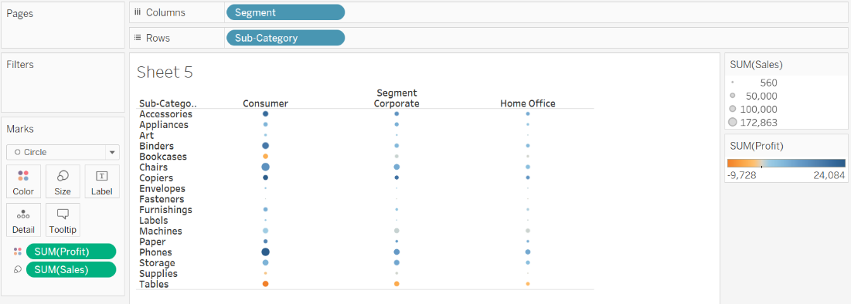

The least profitable sub-category is having the darkest orange color. So tables are the least profitable, and when you hover it, the sales value is **$99,934.**

**Question 2:** As a best practice, what action you would perform on this chart?

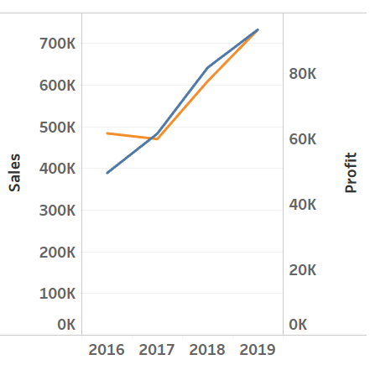

1. Provide the tooltip
2. **Synchronize the axes**
3. Format the labels
4. Hide the header

**Question 3:**

In a scatter plot that shows a negative correlation between values, what it means?

1. Similar trends
2. **Opposing trends**
3. No relation
4. Many outliers

**Question 4:**

Which of the following chart type is best used to investigate the frequency distribution of measure value?

1. Bar chart
2. **Histograms**
3. Tree maps
4. Heat maps